Backend Dashboard & Location Alerts

Overview
The backend now exposes a web-based admin dashboard and a real-time geofence alert system.
When the backend server is running, the dashboard is accessible via:
- Local: http://localhost:8080
- From the dashboard, admins can:
- Manage all participants
- View unique participants stored in the database and their devices.
- Define Red Zones (e.g., bar, dealer location, relapse area) using:
  - GPS coordinates
  - Radius (e.g., 300m)
- Receive real-time geofence alerts when a participant enters a red zone
- Acknowledge alerts directly from the dashboard
- View participants live location.

Geofence Alert Flow
- Admin defines a red zone (coordinates + radius).
- Mobile app sends live location updates.
- Backend evaluates geofence boundaries.
- When a participant enters a red zone:
  - A real-time alert appears in the dashboard.
  - Alert can be acknowledged by an admin.
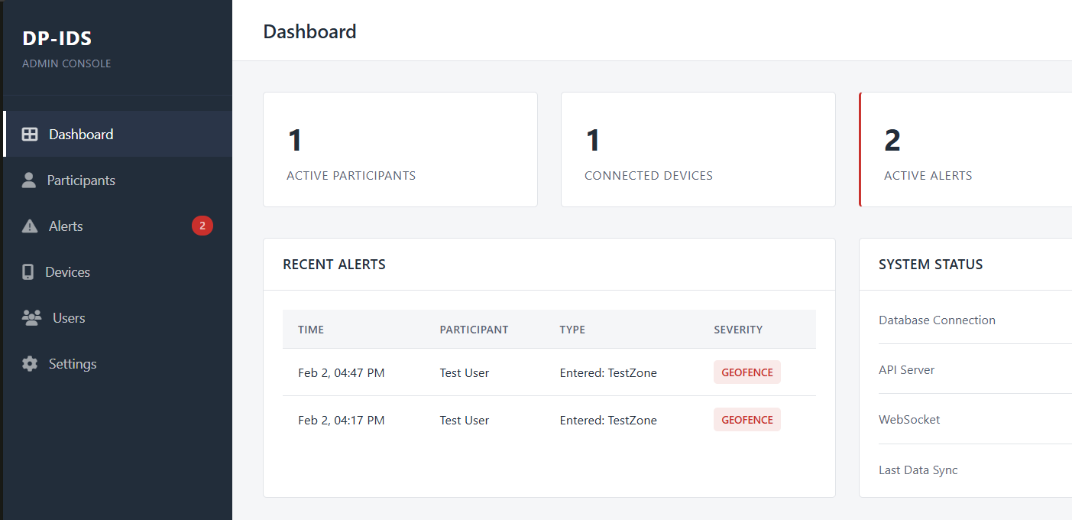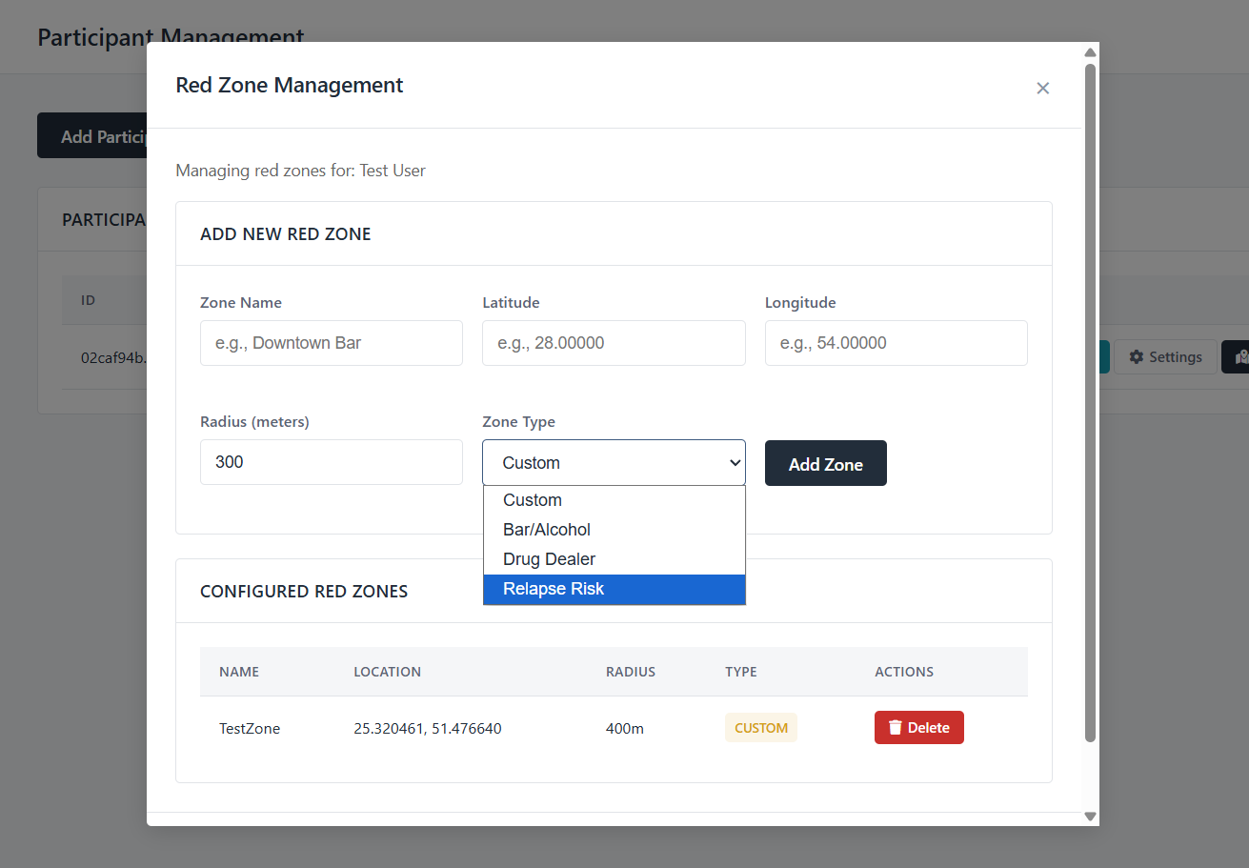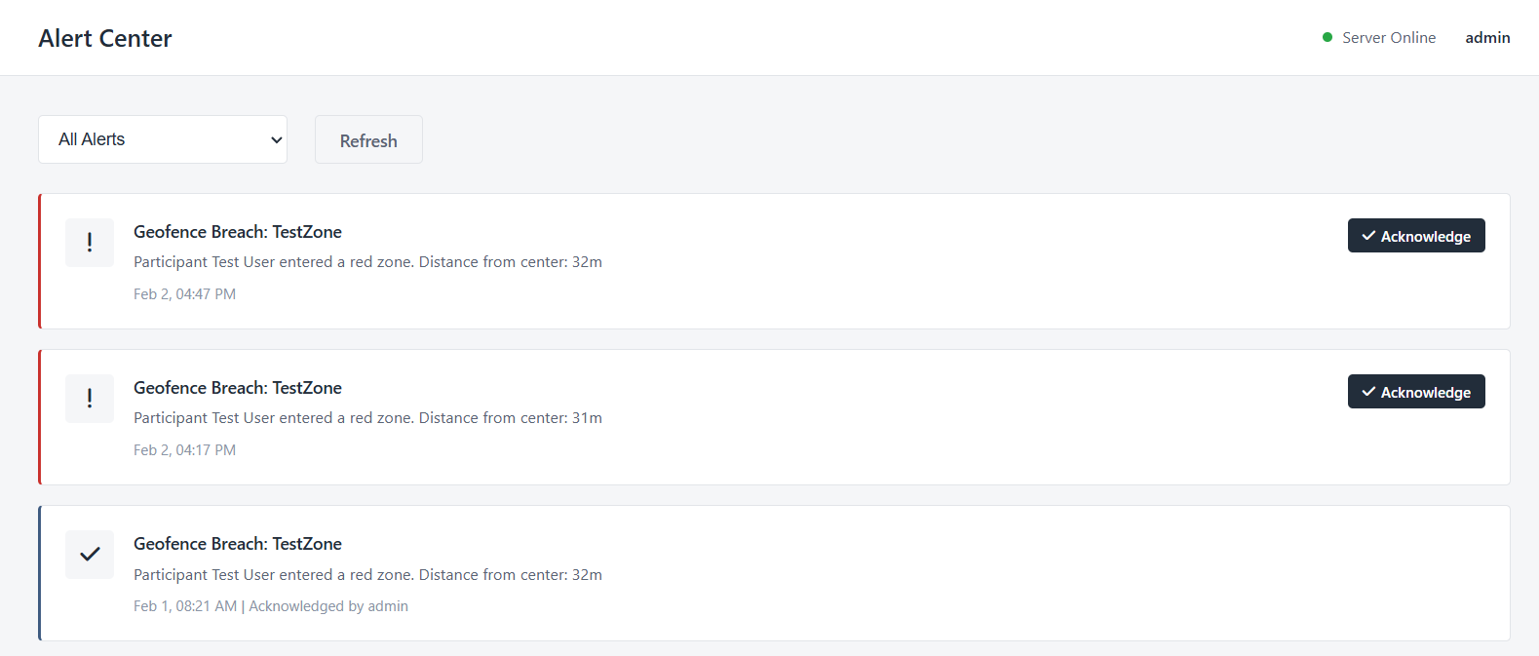

Backend Setup Options

Option 1: Docker (Recommended)
Requirements
- Docker Desktop installed & running
Run
cd backend
docker-compose up --build
This will:
- Start the backend server
- Start a MySQL database
- Auto-create required tables
Dashboard
- URL: http://localhost:8080
- Credentials (no authentication is created yet, put anything):

Option 2: Manual Configuration (Local Setup)
Requirements
- JDK 17
- MySQL 8.0
- Gradle (or included wrapper)
1. Create Database
CREATE DATABASE aware_db;
CREATE USER 'aware_user'@'localhost' IDENTIFIED BY 'password';
GRANT ALL PRIVILEGES ON aware_db.* TO 'aware_user'@'localhost';
FLUSH PRIVILEGES;

2. Start the Server
Windows
cd backend
start-server.bat
Linux / macOS
cd backend
./gradlew run
The server will:
- Build and start automatically
- Create required tables on first run
- Expose the dashboard at http://localhost:8080/dashboard

